Greek Conquest 333 BC- 63 BC ACTIVITY SHEET
- How many period were there in the Jewish History?
- Who was the Persian Empire conquered by?
- Alexander the Great found the city of?
- After Alexander’s death Egypt was rule by?
- What books of the Prophets that were completed during this period?
- What is the first period of Jewish History?
- The ___________ empire was conquered during the Greek conquest
- What family became the high priest family?
- What prophecy spoke about Alexander’s Kingdom?
- What community began in 143BC?
- like a_____________, which had upon the back of it four wings of a fowl;
- the book of Maccabees reflects the traditional Jewish ____________ and also lists the territories
- ______________ is the successor of seleucus
- What language was the bible translated into in 323BC?

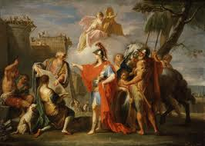

The Greek Conquest word sleuth

k t j c a s h a g d z o a e o
t c j p p p s g r i a k i r l
e p n t p y g e g w x y s u d
a j e j e r u s a l e m a t t
c q p r s t e h p o r p c p e
h n s e s c u l t u r e j i s
i t t i r i p s y l o h z r t
n o s p z g a g z j v n i c a
g r e e k c o n q u e s t s m
s b s c m g j i e a a w l a e
f i u k o u r t g m i r i x n
c b o f d n b i s b p r b s t
g l y e c g i r z h z i y m h
v e a x o m u w n l x o r s k
w v p d b i e p n r y z q e q

asia
bible
culture
egypt
greekconquest
holyspirit
jerusalem
jewish
judea
oldtestament
persianempire
prophets
scripture
syria
teachings
writings

